**ASSIGNMENT 2A – Winter 2018**

Like you, I stood at an intersection at Dundas St and Yonge St. and counted the number of pedestrians crossing the intersection each minute. The data I collected in a 10 minute time period is as follows:



1. Compute by hand (show your formulas) the forecast for minutes 1-4 using the exponential smoothing method with an alpha of 0.3.



1. Now switch to Excel and compute the exponential smoothing forecasts for minutes 11 and 12 (again using an alpha of 0.3). (Show your Formulas)



1. Reforecast minutes 11 and 12 using an alpha of 0.7.



1. Compare how well the model forecast for periods 8-10 for alpha = 0.3 vs alpha =0.7. Which one was better? Explain.



The model at alpha 0.3 was better than the model at alpha 0.7. We know this because we can analyze the model using the Mean Absolute Deviation and Mean Standard Error. We use MAD and MSE to determine the effectiveness of the exponential smoothing relative to the actual results. We wish to reduce the MAD and MSE, as this results in minimization of error in the model. Alpha at 0.3 has a lower MAD and MSE, meaning that it possesses less error relative to the model at an alpha of 0.7. An alpha of 0.3 is better.

1. Explore your model to better understand how exponential smoothing works (a graph might help):
   1. Which produces a smoother forecast, a high alpha or a low alpha?

Viewing the graph above, it is clear that the lower alpha produces a smoother forecast. This can be justified by examining the equation to determine the forecast; a lower alpha will prevent big differences between forecast and actual from playing a large impact on the newly forecasted alpha.

* 1. Which results in a forecast that is more responsive to new data – a high alpha or a low alpha?

The higher alpha. This is because, compared to the lower alpha, the higher alpha gives higher value to the difference between forecasted values and actual values. Therefore, when there is new data that may not be similar to that which was forecasted, the higher alpha will give weight to the difference between forecast and actual.

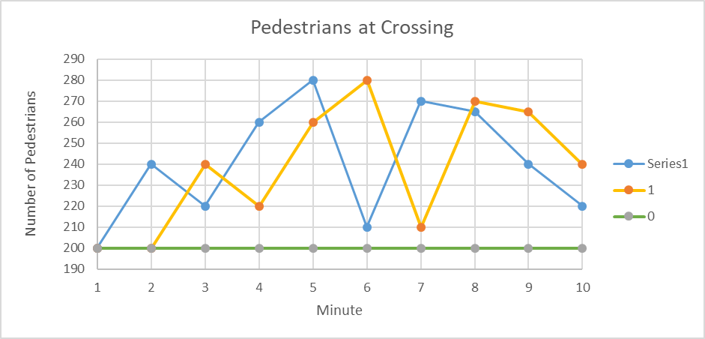

* 1. What happens when alpha = 1?

When alpha = 1, the forecast is equal to the precious actual data. This is because the difference between what was forecasted and what actually happened is given full weight, which then results in a “forecast” which is equal to the previous actual result.

* 1. What happens when alpha = 0?

With an alpha of 0, there is no weight given to changing actual data points. This means that the forecast stays constant over the full period of time, or in this case, over all 10 minutes.

* 1. What happens when you try to forecast many periods into the future?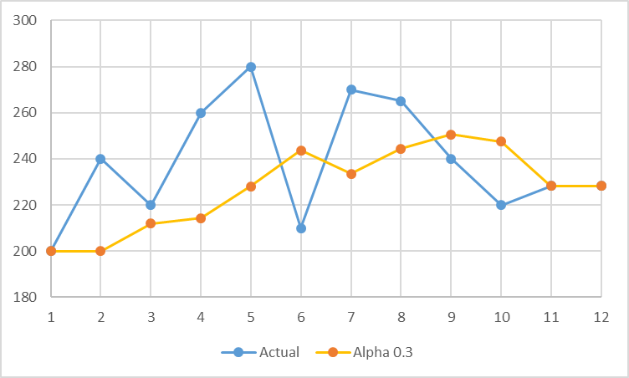

when you try to forecast into the future, the data will flat out right away. This is because the new “actual” data is the forecasted data from the previous time series. Therefore, when we go to forecast new data, there is no difference between forecasted and “actual” data, and therefore, the data flatlines.

* 1. 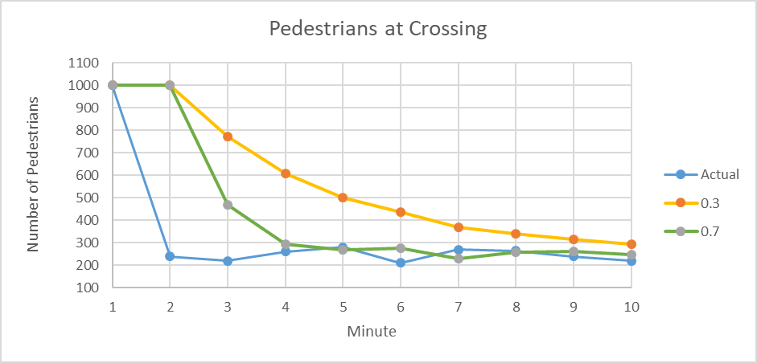Try a different starting value for Ft. (Pick something extreme like 0 or 1000.) Does the starting value for Ft significantly impact future forecasts?

Dependant on the alpha, the initial value will or will not have an impact on future forecasts. With a higher alpha, outliers are more quickly filtered out of the future forecasts as there is more importance placed on recent changes in data. With a lower alpha, the initial value will play a greater role on the future forecasts, and the initial “outlier” will impact the future forecasts. Impact of outliers, whether initially or in the middle of the data series, are determined by the alpha; a lower alpha gives significance to outliers whereas a higher alpha gives significance to the most recent data.